Here are some of the top areas in Dubai for property purchases, with short descriptions and visual map context (distance from Dubai Mall):

1. Downtown Dubai (Prime Core Investment Zone)
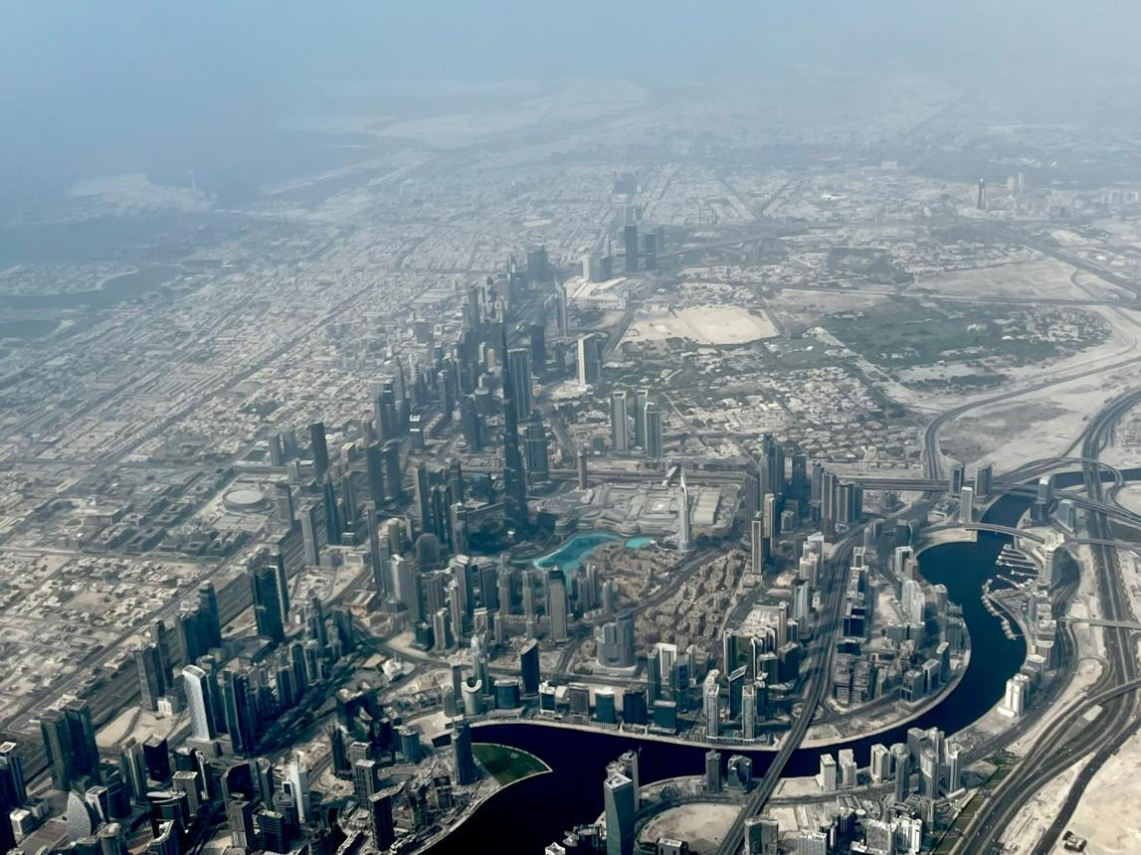
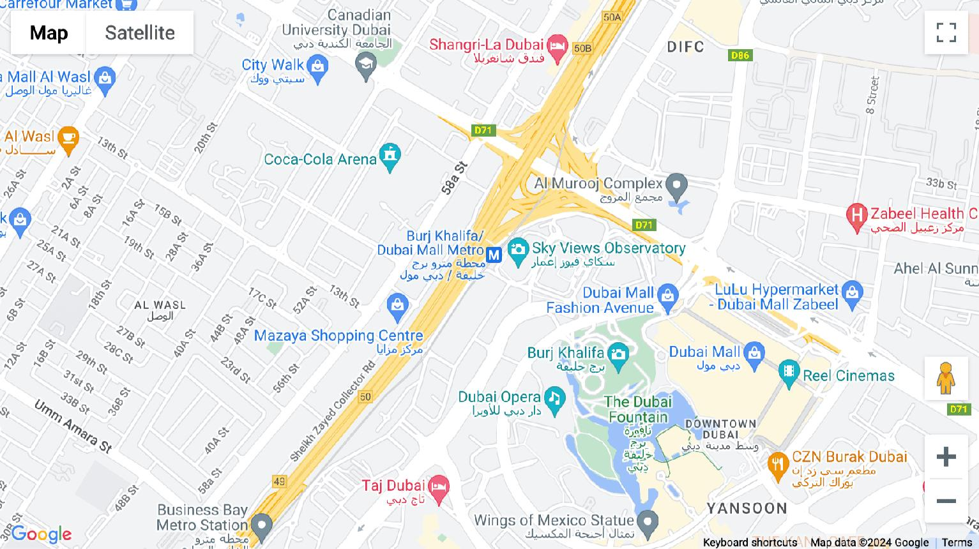
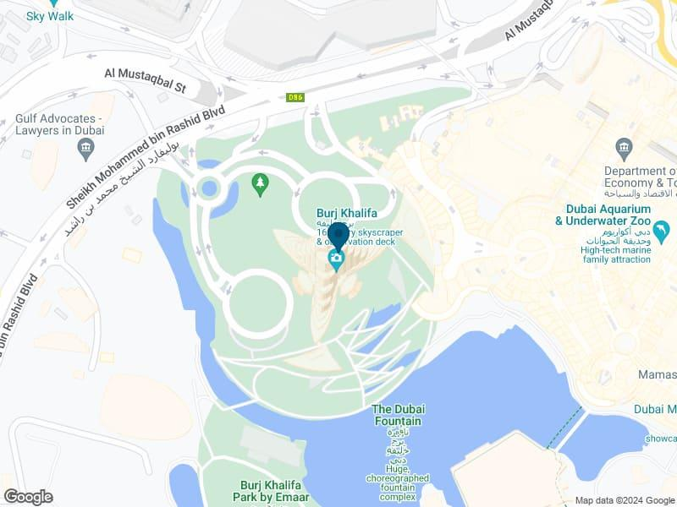
4
Distance from Dubai Mall: 0–1 km
Overview:
The heart of Dubai and home to iconic landmarks like Burj Khalifa. This is the most premium and high-demand area for both short-term rentals and luxury living.
Why Invest:
- Highest rental yields for short-term (Airbnb-style)
- Strong capital appreciation
- Walkable lifestyle + tourism hub

2. Business Bay (Urban Growth Hub)

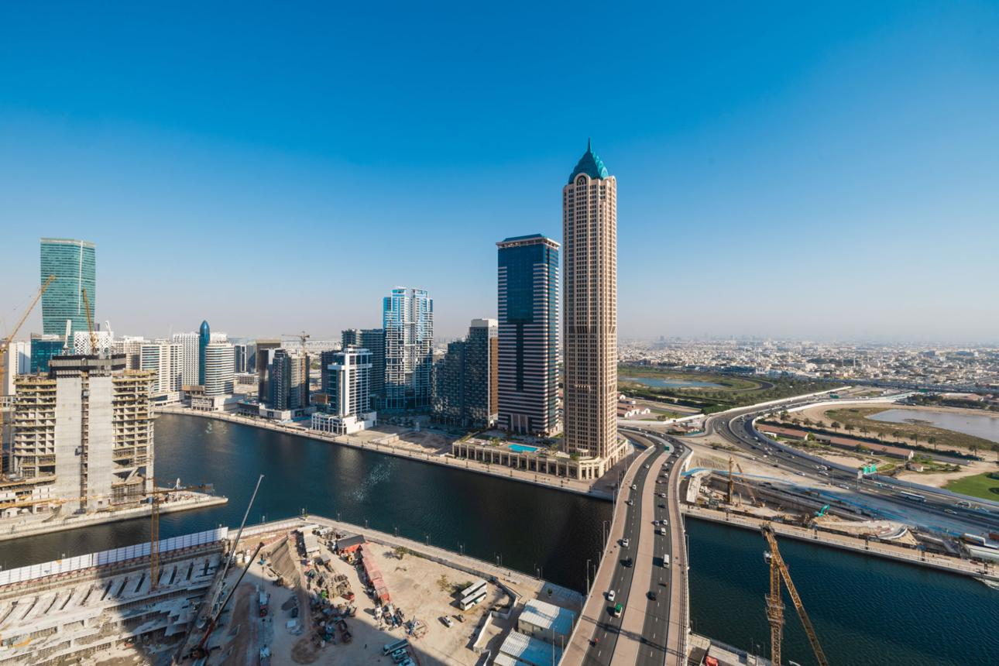
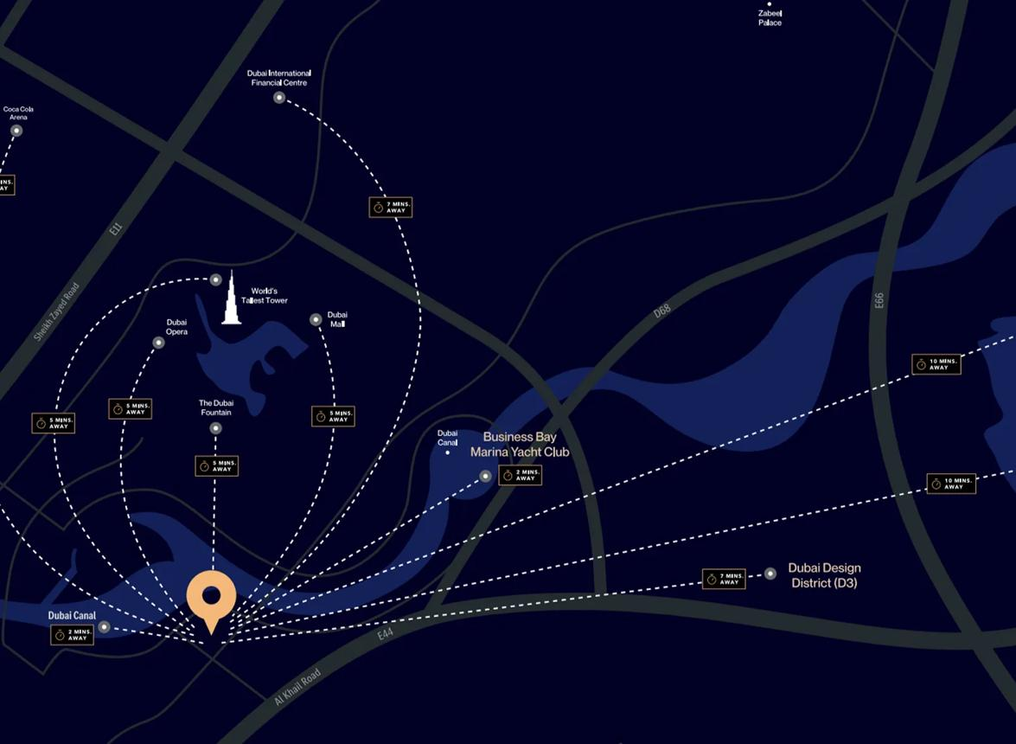
4
Distance from Dubai Mall: 2–3 km
Overview:
A fast-growing commercial and residential district next to Downtown, centered around the Dubai Canal.
Why Invest:
- Slightly more affordable than Downtown
- Strong rental demand from professionals
- Rapid development = future appreciation

3. Dubai Marina (Waterfront Lifestyle Investment)
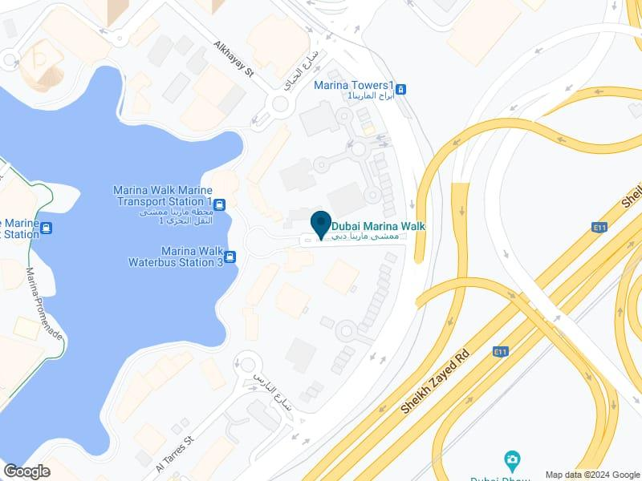
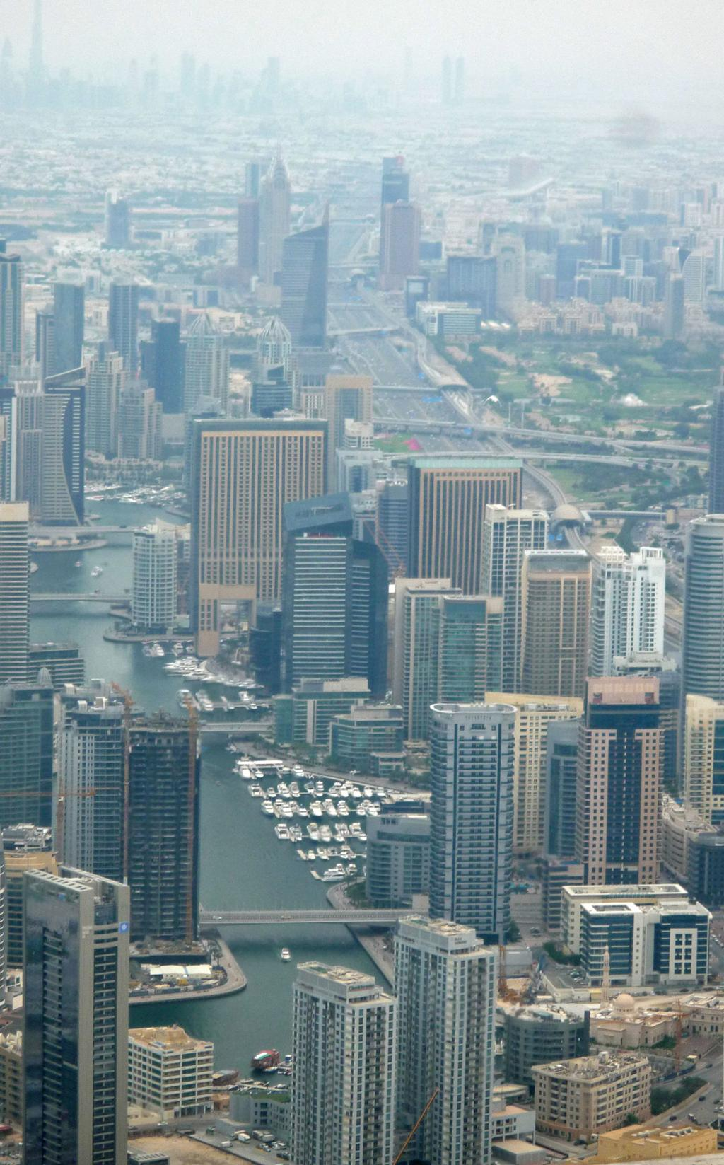
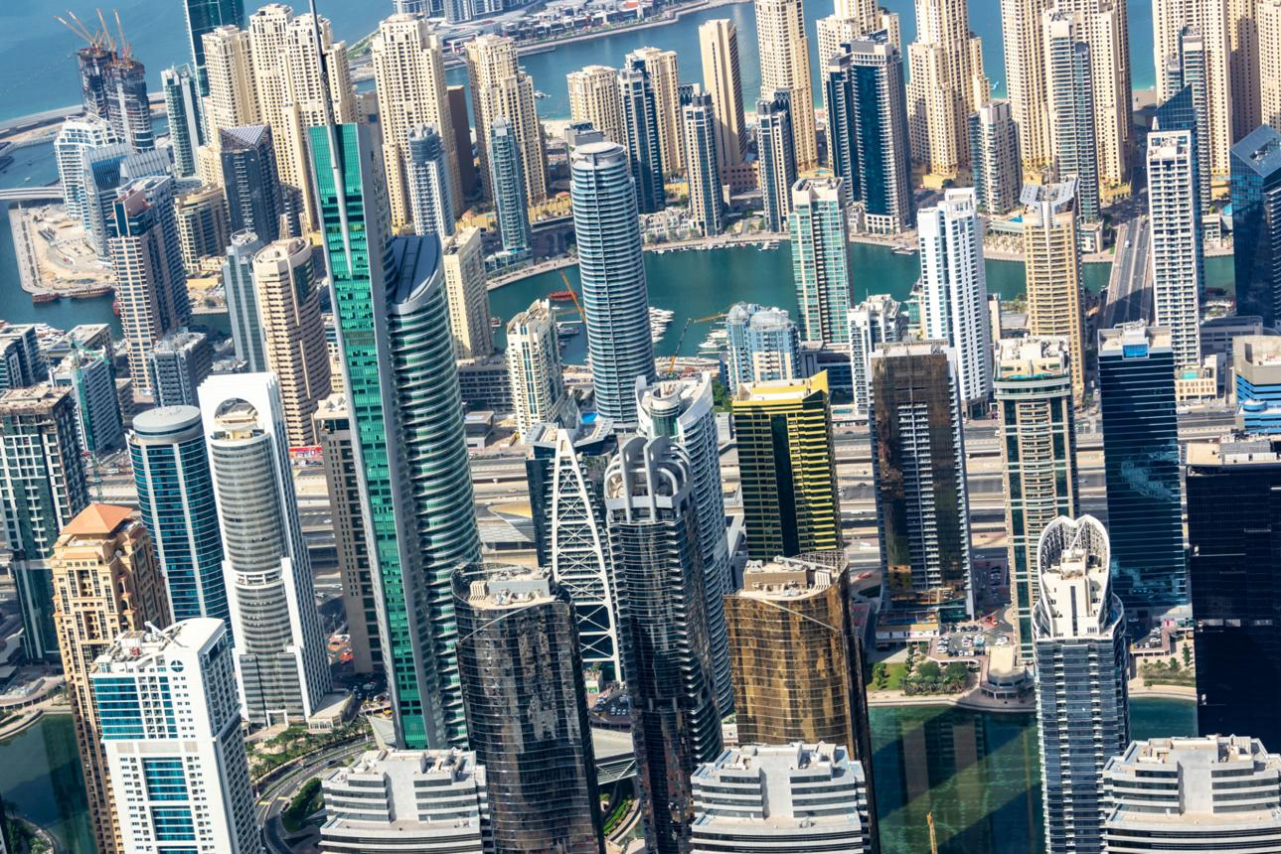
4
Distance from Dubai Mall: 20–25 km
Overview:
A vibrant waterfront community popular with expats, tourists, and young professionals.
Why Invest:
- High rental demand
- Strong resale liquidity
- Lifestyle-driven (beach, dining, nightlife)

4. Palm Jumeirah (Ultra-Luxury Segment)

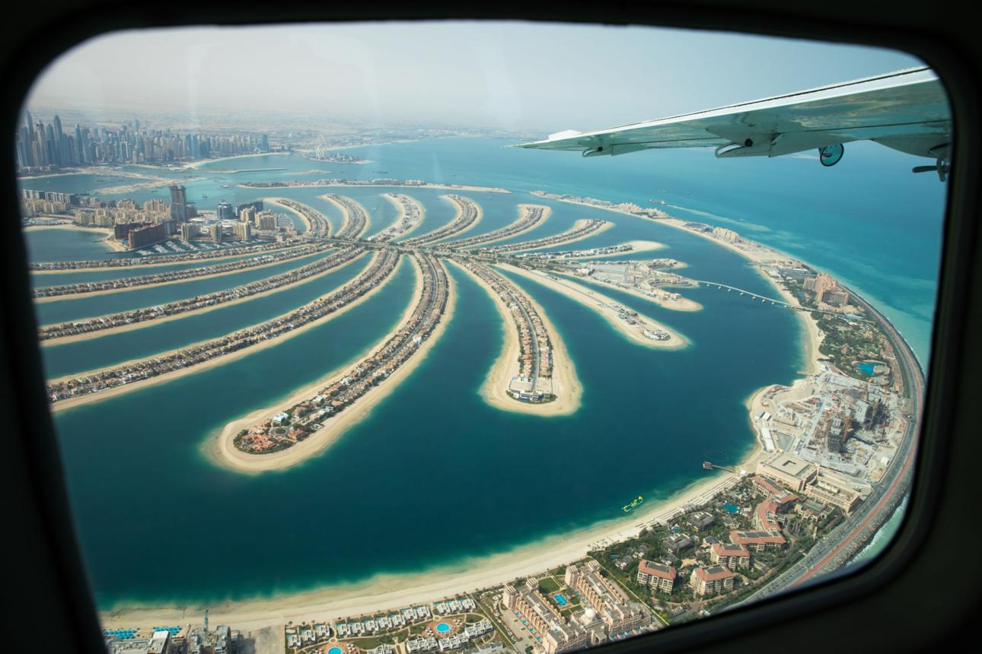
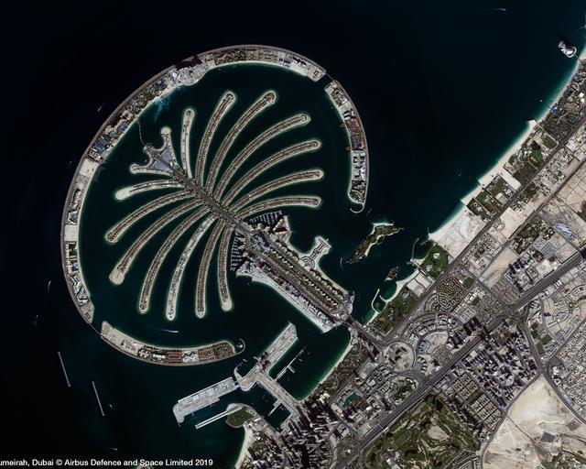
4
Distance from Dubai Mall: 25–30 km
Overview:
An iconic man-made island known for ultra-luxury villas and beachfront apartments.
Why Invest:
- Premium clientele & high-net-worth buyers
- Limited supply = strong long-term value
- High-end rental returns

5. Dubai Hills Estate (Modern Family Community)
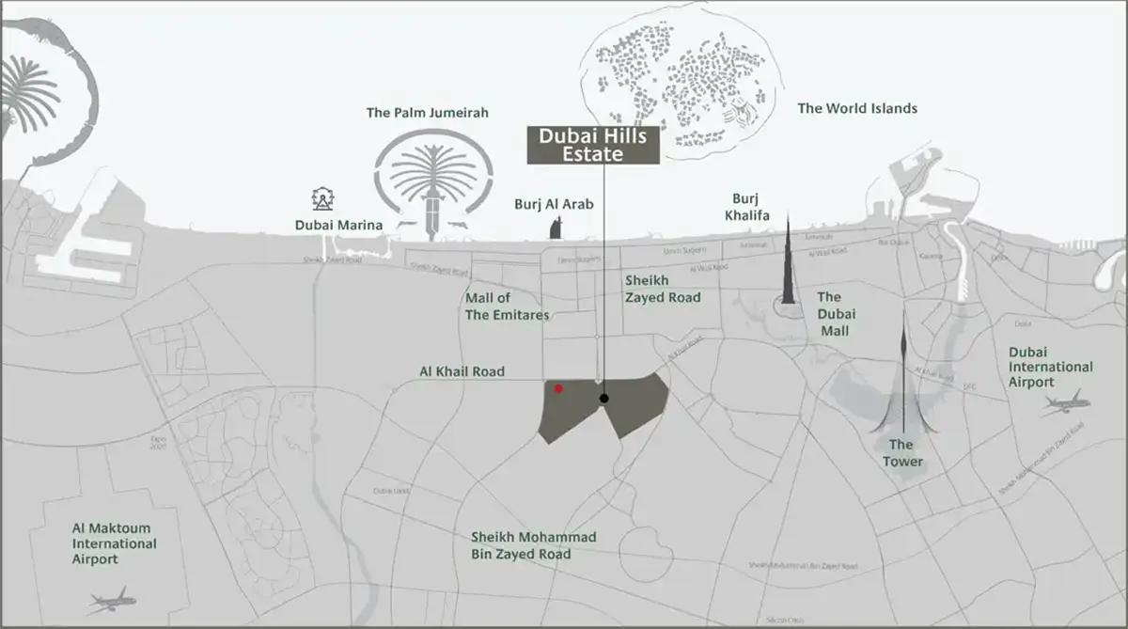
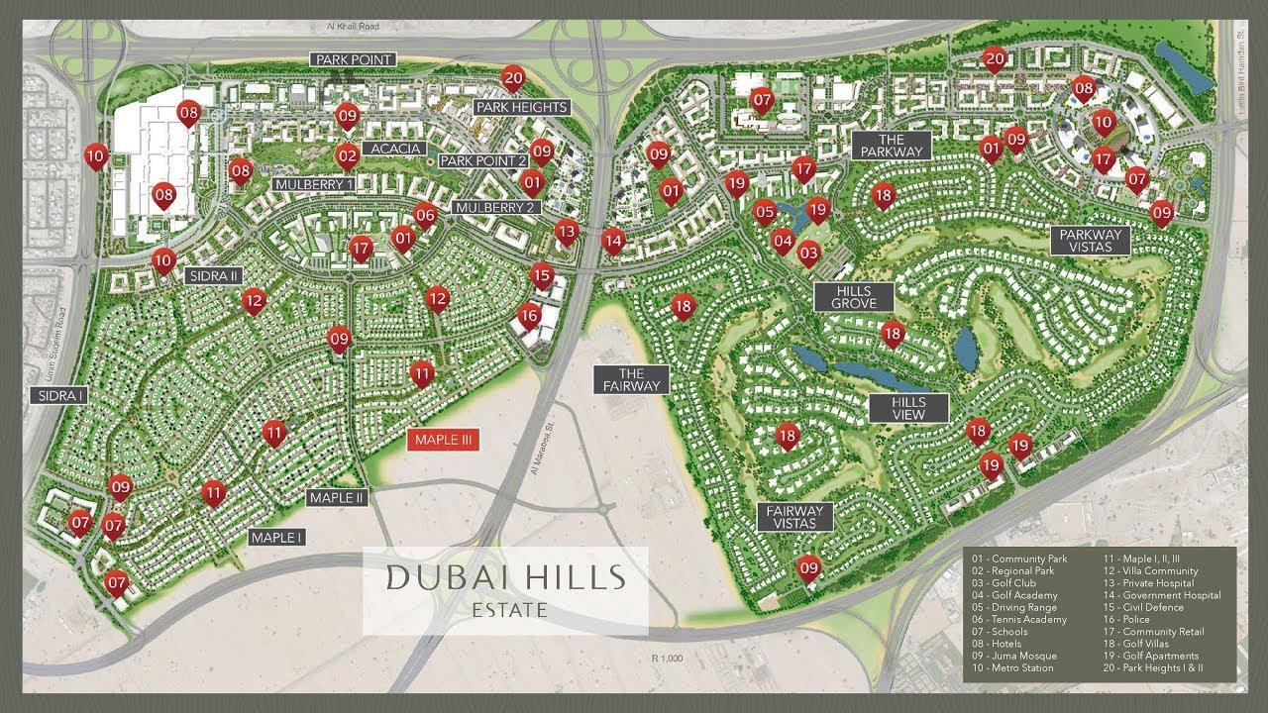
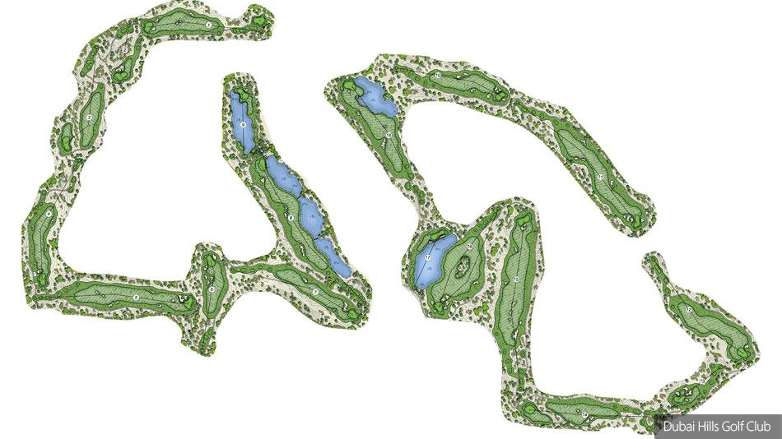
4
Distance from Dubai Mall: 10–15 km
Overview:
A master-planned community by Emaar Properties, offering villas, townhouses, and apartments.
Why Invest:
- Balanced pricing + quality living
- Ideal for families (schools, parks, mall)
- Long-term capital appreciation

6. Jumeirah Village Circle (JVC) (Affordable High ROI Zone)
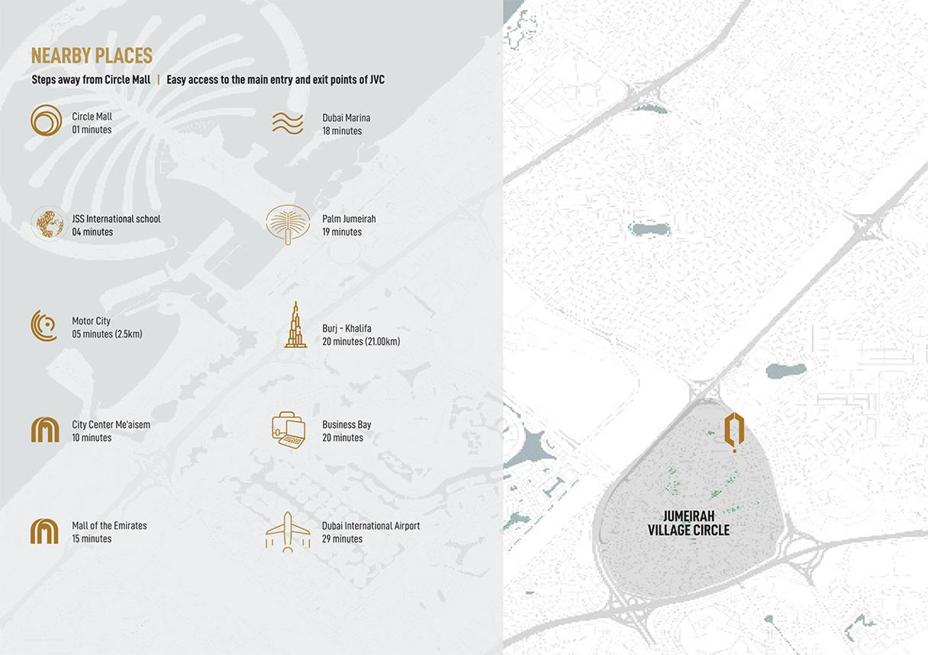
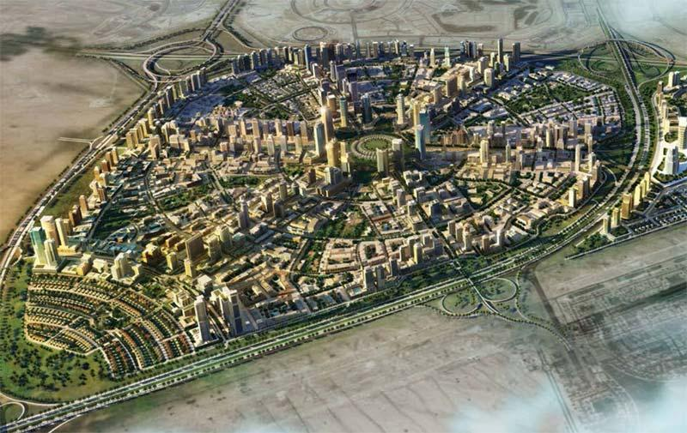
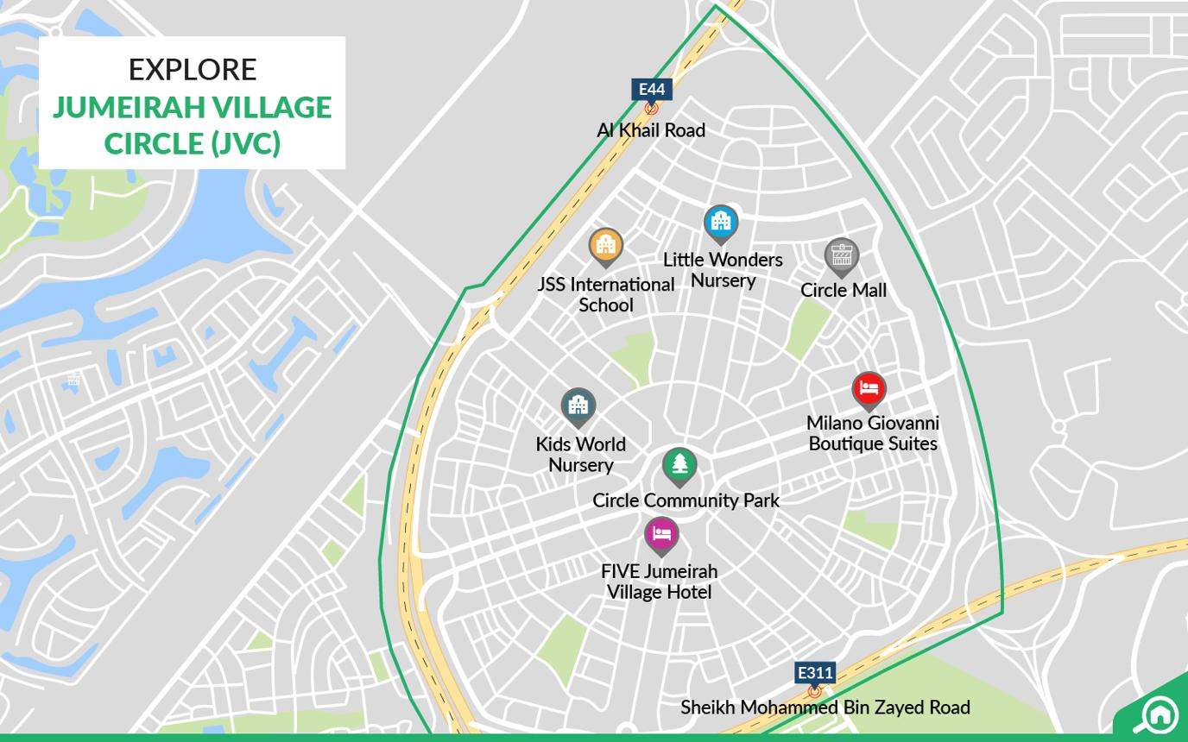
4
Distance from Dubai Mall: 15–20 km
Overview:
A rapidly developing residential area known for affordability and strong rental yields.
Why Invest:
- High ROI (rental yield 6–8%+)
- Entry-level pricing for investors
- Growing infrastructure

7. Dubai Creek Harbour (Future Downtown Alternative)
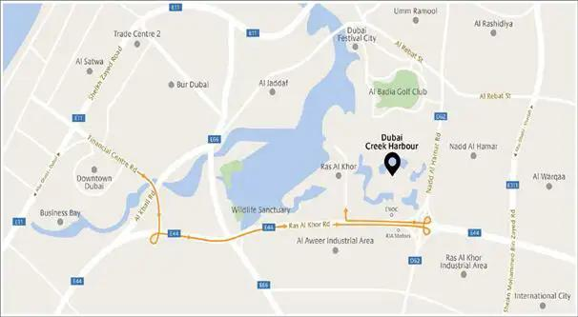
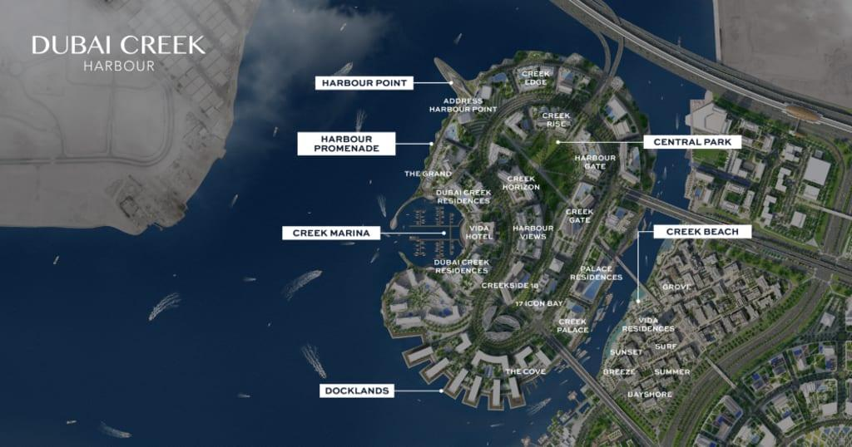
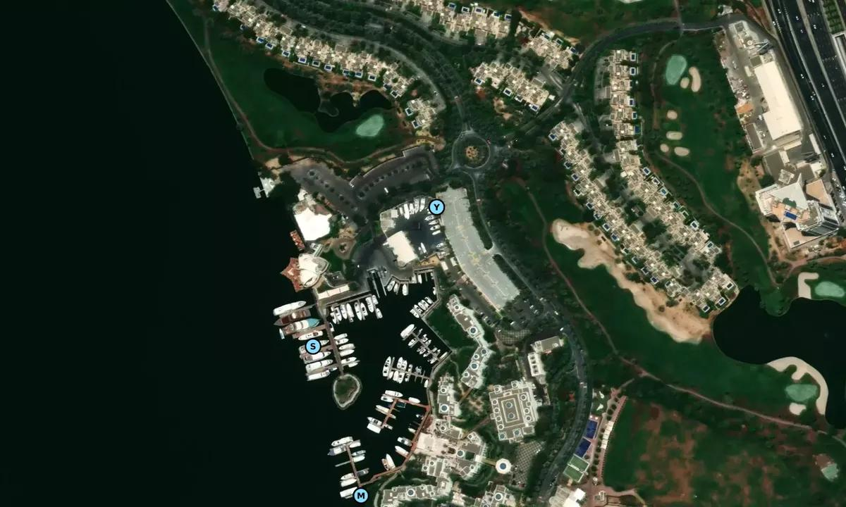
4
Distance from Dubai Mall: 10–15 km
Overview:
An emerging waterfront destination expected to rival Downtown in the future.
Why Invest:
- Early-stage investment opportunity
- Massive planned development
- High future upside

8. Arabian Ranches (Villa Community Investment)
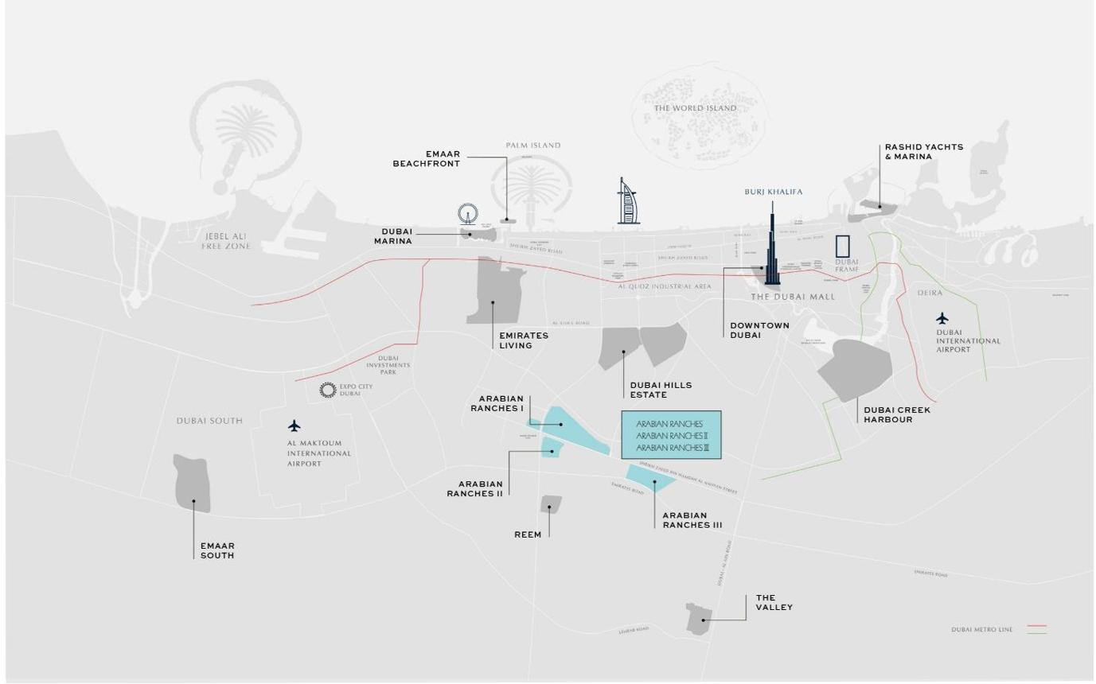
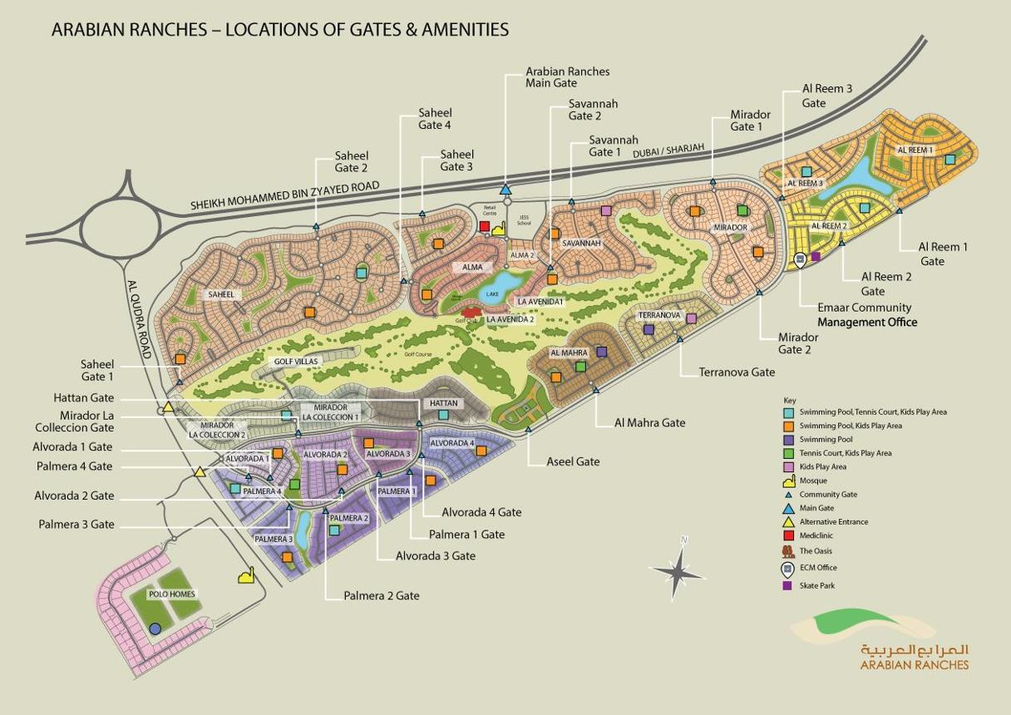
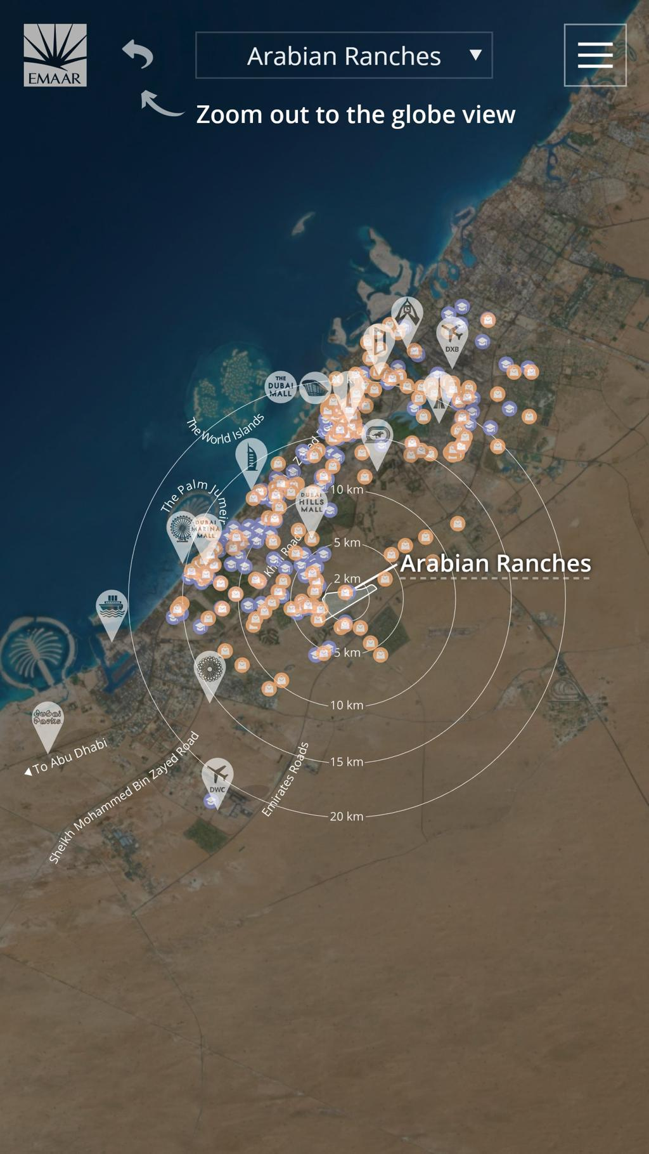
4
Distance from Dubai Mall: 20–25 km
Overview:
A well-established villa community ideal for families.
Why Invest:
- Stable long-term returns
- Strong end-user demand
- Premium suburban living

Strategic Insight (Important for Your Project)
For your Your Homes / MorangoAi real estate positioning, these areas can be grouped as:
- Luxury Core: Downtown, Palm Jumeirah
- High Yield / Rental: Business Bay, JVC
- Lifestyle Premium: Dubai Marina, Dubai Hills
- Future Growth: Dubai Creek Harbour
- Family Villas: Arabian Ranches

